SKILL 3 & 4
3. To Apply Escape Sequences, Store Command History, Navigate Previous Commands, Navigate Next Commands, Update Input Buffer, Test Recall Functionality.
To Allocate Buffers Dynamically, Resize Arrays, Prevent Buffer Overflow, Manage Linked Lists, Release Memory Correctly, Verify with Valgrind.
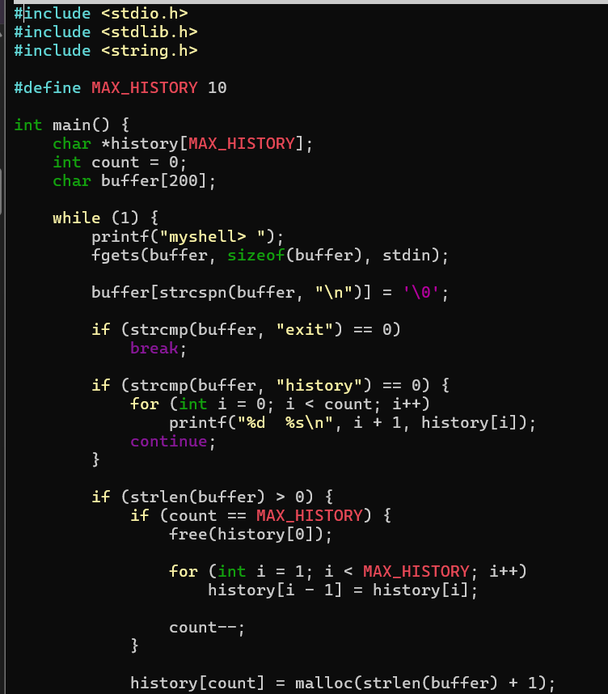
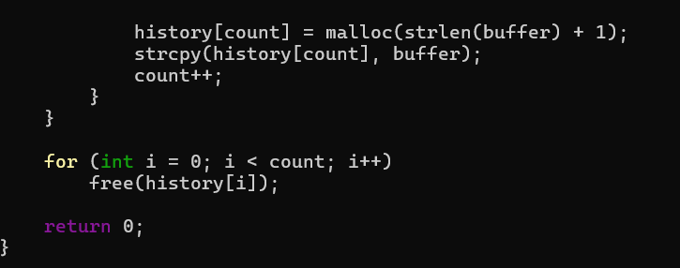
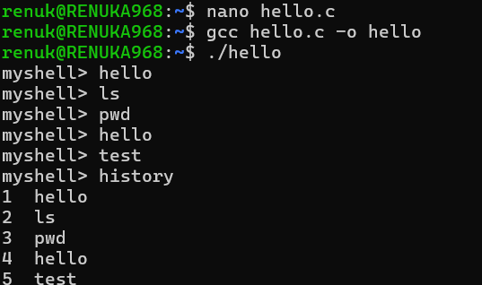

- To Split Input into Tokens, Identify Delimiters, Handle Whitespace, Create Token Structures, Validate Token Streams, Debug Parsing Output.

To Design Parser Logic, Generate Parse Trees, Validate Syntax, Detect Errors, Handle Empty Commands, Produce Execution Structures.

